Conversion and reshaping of numpy array.

The input images first converted to numpy array which were holding continuous values.

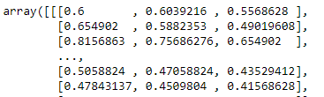

Then reshaped it so that there will be only three columns will consist r,g,b values for each pixel of the image.

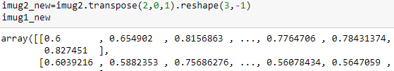

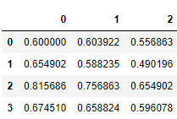

Initial modelling of linear regression:

After array reshaping of predicted array into binary class.

We put the threshold at 0.55, if any of the continuous values goes up the 0.55 then encoded as 1 Else 0. 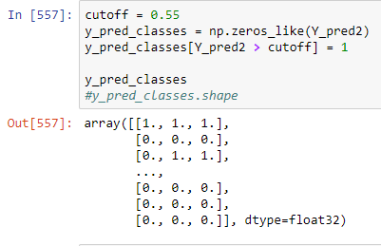

Confusion matrix for predicting true values.

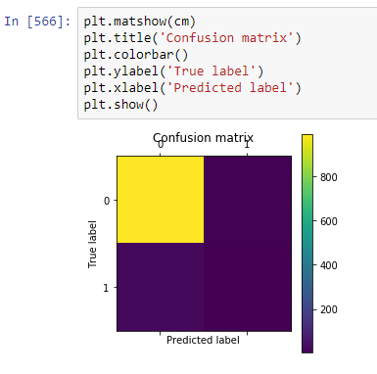

Revert back to jpeg image.

